**Intrusion Detection System**

**A PROJECT REPORT**

***Submitted by***

**Urmit Tajwala(20210702089)**

**Under the guidance of**

**Ms. Divya Mohan**

***In partial fulfilment for the award of the degree of***

**B.Tech(Computer Science and Engineering with specialization in Artificial Intelligence and Machine Learning)**

**(Batch 2021-2025)**

Unitedworld School Of Computational Intelligence



**April 2024**



**BONAFIDE CERTIFICATE**

Certified that this project report **Intrusion Detection System** is the bonafide work of **Urmit Tajwala (20210702089)** who carried out the project work under my supervision as a part of 21BTCS99E03 – Industry Elective-3.

*SIGNATURE* *SIGNATURE*

**Ms. Divya Mohan          Dr. RAJU SHANMUGAM**

**Assistant Professor Professor & Dean**

USCI, Karnavati University USCI, Karnavati University

Gandhinagar Gandhinagar

Gujarat- 382422 Gujarat-382422

##### Karnavati University - Wikipedia

**VIVA-VOCE EXAMINATION**

The viva-voice examination of the project work titled " **Intrusion Detection System"** submitted by **Urmit Tajwala (20210702089)** is held on

**INTERNAL EXAMINER EXTERNAL EXAMINER**

**ACKNOWLEDGEMENT**

I thank the **Almighty** for showering his blessing upon me in completing the project. I submit this project with a deep sense of gratitude and reverence for my beloved parents for their moral support and encouragement.

I express my sincere gratitude to **Dr.RAJU SHANMUGAM**, Professor & Dean, Department Of Computer Engineering, Unitedworld School of Computational Intelligence for providing strong oversight of vision, strategic direction, encouragement and valuable suggestions.

I convey my earnest thanks to **Ms. Divya Mohan**, Assistant Professor, Department Of Computer Applications, for her valuable guidance and support throughout the project.

I extend my sincere thanks to all my staff members for their valuable suggestions, timely advice and support throughout.

**Urmit Tajwala**

**Abstract**

*In today's interconnected digital landscape, the security of computer networks is paramount. In this Project named Intrusion Detection Systems (IDS) play a crucial role in safeguarding the networks by detecting and mitigating various forms of unauthorized access and malicious activities right now we have used a Signature Based Dataset in which there is pre-defined intrusion from that we can compare to detect the intrusion.*

INDEX

|  |  |
| --- | --- |
| **CONTENTS** | |
| Chapter No. | Description | Page No. |
|  | **Figure Details** |  |
|  | * 1. Upload Train Page   2. Upload Test Page   3. Result Page |  |
| **1** | **Introduction** | **1-5** |
|  | 1. Project Details   1.2 Project Purpose  1.3 Project Scope  1.4 Project Objective |  |
| **2** | **Technology & Tools Used** | **6-11** |
|  | 2.1 Introduction to HTML  2.2 Introduction to CSS  2.3 Introduction to PYTHON  2.4 Introduction to FLASK  2.5 Introduction to POSTGRES |  |
| **3** | **System Requirements** | **12-14** |
| 4 | **Screen layouts and Snapshot** | **15** |
| **5** | **Limitations and Future Extensions** | **16** |
|  |  |  |
| **6** | **Conclusion & Reference** | **17** |
| **7** | **Report Verification Procedure** |

**Introduction**

* 1. **Project Details:**

Intrusion detection is a cybersecurity technique that involves monitoring computer networks and systems to detect unauthorized access, suspicious activities, or potential security threats. It works by analysing network traffic and system logs for patterns or behaviours that deviate from established norms. When anomalies are identified, the intrusion detection system generates alerts or notifications, enabling timely responses to mitigate potential risks. Intrusion detection plays a critical role in safeguarding digital assets, maintaining network security, and protecting against cyberattacks, making it an essential component of modern cybersecurity strategies.

Intrusion Detection Systems (IDS) offer several key benefits in network security. Firstly, they provide real-time monitoring, swiftly identifying and alerting to unauthorized access or malicious activities, reducing response time to potential threats. Secondly, IDS helps in minimizing false positives, ensuring that security teams focus on genuine risks. Thirdly, they aid in safeguarding data integrity, confidentiality, and system availability, crucial for business continuity. Fourthly, IDS can detect both external threats and insider risks, bolstering overall security. Furthermore, IDS systems support regulatory compliance, essential for organizations in various industries. Lastly, continuous analysis and improvement of IDS strengthen the organization's resilience against evolving cyber threats, making it a cornerstone of modern cybersecurity strategies.

Another significant benefit of Intrusion Detection Systems (IDS) lies in their ability to provide valuable forensic data and insights. In the event of a security incident, IDS logs and alerts offer a detailed record of the attack, including its origin, method, and potential vulnerabilities exploited. This forensic information is instrumental in post-incident analysis, aiding in understanding the nature of the breach and informing strategies to prevent future attacks. Additionally, it can be crucial in legal and regulatory contexts, helping organizations comply with reporting requirements and potentially supporting legal actions against perpetrators. IDS's role as a valuable investigative tool enhances an organization's ability to learn from security incidents and fortify its defences for the future.

* 1. **Project Purpose:**

An Intrusion Detection System (IDS) serves a critical purpose in modern cybersecurity, acting as a vigilant guardian tasked with enhancing the security and integrity of computer systems and networks. Its multifaceted role encompasses threat detection, real-time monitoring, alert generation, reduction of false positives, incident response facilitation, compliance enforcement, forensic analysis support, insider threat detection, network security reinforcement, and adaptation to evolving threats.

* **Threat Detection:**

The fundamental purpose of an IDS is to detect and identify potential security threats. These threats can range from unauthorized access attempts to sophisticated cyberattacks. By analyzing network traffic and system logs, an IDS identifies abnormal patterns or behaviors that deviate from established norms. It acts as a virtual watchdog, continuously scrutinizing data flows to identify any activities that may pose a risk to the organization's digital assets.

* **Real-Time Monitoring:**

Intrusion Detection Systems provide real-time monitoring of network traffic and system events. This capability allows them to identify security incidents as they occur, providing immediate awareness of potential threats. Real-time monitoring is essential in the fast-paced world of cybersecurity, where the speed of detection can be a critical factor in minimizing the impact of an attack.

* **Alert Generation:**

When suspicious or malicious activities are detected, an IDS generates alerts or notifications. These alerts are invaluable for informing cybersecurity teams or administrators about potential threats. Rapid notification enables security personnel to initiate timely responses, investigate the incidents, and take appropriate action to mitigate the risks.

* **Reducing False Positives:**

One of the challenges in intrusion detection is the potential for false positives, where legitimate activities are incorrectly identified as threats. An effective IDS is designed to minimize false alarms by employing sophisticated algorithms and finely tuned rules. Reducing false positives is essential to prevent alert fatigue, ensuring that security teams can focus their efforts on genuine security risks.

* **Incident Response Facilitation:**

Intrusion Detection Systems play a vital role in incident response. They provide early warnings and detailed information about security incidents, enabling security teams to respond rapidly and effectively. Incident response may involve isolating affected systems, analyzing the nature of the attack, patching vulnerabilities, and recovering from the incident. IDS facilitates this crucial process by pinpointing the source and method of the attack.

* **Forensic Analysis Support:**

In the aftermath of a security incident, an IDS provides valuable forensic data. This data includes information about the attack's origin, method, and potential vulnerabilities exploited. Forensic analysis aids in understanding the nature of the security breach, identifying weaknesses in security measures, and improving future security strategies.

* **Insider Threat Detection:**

While external threats are a concern, insider threats can also pose significant risks. An IDS can detect unauthorized or suspicious activities initiated by employees or trusted entities within the organization. This capability helps organizations safeguard against internal threats that may compromise data integrity or confidentiality.

* **Network Security Reinforcement:**

Intrusion Detection Systems play a pivotal role in enhancing overall network security. By identifying vulnerabilities and potential attack vectors, they contribute to the prevention of security breaches. This reinforcement involves both proactive measures, such as identifying and patching vulnerabilities, and reactive measures, such as isolating compromised systems.

* **Adaptation to Evolving Threats:**

Cyber threats are constantly evolving, with attackers developing new tactics and exploiting emerging vulnerabilities. IDS systems must adapt to these evolving threats to remain effective. Regular updates, signature updates, and rule adjustments are essential to ensure that the IDS can detect and respond to new attack methods.

* 1. **Project Scope:**

The scope of an Intrusion Detection System (IDS) is extensive and plays a pivotal role in bolstering an organization's cybersecurity defences. At its core, an IDS is designed to monitor and safeguard both network and host environments against unauthorized access, malicious activities, and potential security threats.

In the realm of network security, IDS systems continuously analyses incoming and outgoing network traffic. They meticulously scrutinize data packets, network protocols, and communication patterns, seeking any deviations from established norms. This real-time monitoring is fundamental in the detection of anomalies and potential intrusions. When suspicious activities are identified, IDS systems generate alerts and notifications, enabling security teams or administrators to respond promptly and effectively. The scope of IDS also extends to supporting incident response efforts, providing early warnings and detailed information about security incidents. This feature aids in investigations, the analysis of attack vectors, and the mitigation of security breaches.

An IDS employs multiple methods for detecting threats, including signature-based detection, where predefined patterns or signatures of known threats are matched against network traffic. Additionally, anomaly-based detection examines deviations from normal network or system behaviour, allowing for the identification of emerging or previously unknown threats. The scope of IDS includes rule-based analysis, where predefined rules dictate what activities are considered normal or suspicious. This flexibility allows organizations to tailor their intrusion detection strategies to their specific security needs.

Beyond these technical aspects, IDS systems also encompass compliance and reporting functionalities. They help organizations adhere to regulatory requirements and industry-specific standards by generating reports and logs that document security events and activities. This capability is vital for auditing, compliance, and legal purposes. Furthermore, IDS contributes to the overall enhancement of network security by identifying vulnerabilities, potential attack vectors, and weak points in the network infrastructure. By actively participating in proactive measures such as patching vulnerabilities and tightening security controls, IDS systems contribute significantly to an organization's cybersecurity posture.

In an ever-evolving threat landscape, IDS systems must adapt to emerging cyber threats continually. Regular updates, signature updates, and rule adjustments are essential to ensure that the system remains effective in detecting and responding to new attack methods. Additionally, the scope of IDS extends to its seamless integration with other security tools and systems, creating a unified security ecosystem that works cohesively to protect an organization's digital assets.

* 1. **Project Objective:**

The primary objectives of an Intrusion Detection System (IDS) are to enhance cybersecurity and protect an organization's digital assets. IDS achieves these goals through real-time monitoring, threat detection, and incident response facilitation.

Firstly, IDS continuously monitors network traffic and system activities, operating in real-time to identify unauthorized access, suspicious behaviours, and potential security threats as they occur. This proactive monitoring helps in minimizing response time, reducing the potential impact of cyberattacks.

Secondly, IDS serves as a vigilant guardian, detecting threats through multiple methods. Signature-based detection identifies known threats by matching predefined patterns, while anomaly-based detection identifies deviations from normal behaviour, including emerging or previously unknown threats.

Thirdly, IDS generates alerts or notifications upon detecting suspicious activities, enabling swift response by security teams or administrators. It reduces false positives through fine-tuning, ensuring that alerts focus on genuine security risks, preventing alert fatigue.

Moreover, IDS supports incident response efforts, providing early warnings and detailed information about security incidents. It aids in investigations, analysis, and breach mitigation.

**Technology & Tools Used**

The technologies that we have used in our system have been listed below:

**2.1 INTRODUCTION TO HTML**



* Hypertext Markup Language (HTML) is a cornerstone technology that underpins the World Wide Web. It serves as the fundamental language for creating, structuring, and presenting content on web pages. HTML provides a standardized and structured approach to web development, enabling developers to define the layout, format, and interactivity of web-based documents.
* HTML documents are constructed using a system of tags enclosed in angle brackets ("<" and ">"). These tags define the elements of a web page and their attributes. The use of opening and closing tags creates a hierarchical structure that organizes content into headings, paragraphs, lists, links, and more.
* HTML employs a wide range of elements to format and structure content. Elements such as <p> for paragraphs, <h1> to <h6> for headings, and <a> for hyperlinks are foundational to web page construction. These elements define the semantic structure of the document.
* Every HTML document begins with a <!DOCTYPE> declaration, which specifies the HTML version being used. This declaration ensures that web browsers interpret and render the content correctly. HTML5 is the latest and most widely adopted version, offering advanced features and enhanced semantics.
* The <html> element serves as the root of an HTML document. It encapsulates the entire content of the web page and provides essential information about the document.
* The <head> section contains metadata that informs web browsers and search engines about the document. Metadata includes the page's title, character encoding, and references to external resources such as stylesheets and JavaScript files.
* The main content of a web page resides within the <body> section. This is where you insert text, images, multimedia, links, and other elements that users interact with and view when they visit the web page.
* HTML enables the creation of hyperlinks using the <a> (anchor) tag. Hyperlinks allow users to navigate to other web pages, resources, or specific sections within the same page. Properly crafted links enhance the user experience and facilitate website navigation.
* HTML supports the creation of both ordered and unordered lists. The <ol> tag is used for ordered lists, while the <ul> tag is employed for unordered lists. List items are defined using the <li> tag, allowing for the organized presentation of information.
* With the introduction of HTML5, semantic elements like <header>, <nav>, <main>, <section>, <article>, and <footer> have become integral to HTML. These elements add meaning to the structure of a web page, enhancing its accessibility and search engine optimization (SEO)
  1. **Introduction to CSS:**



* With HTML styles, each use of that font would require a different font change, which would need to be done repeatedly.
* The position and appearance of text and other items on your website can both be controlled using CSS.
* While styles specify how the objects should look, HTML information generates the objects (or gives them meaning).
* Your page's structure is provided by the HTML, and its "presentation" is made by the CSS. A text file with a .css extension
  1. **Introduction to Python:**



• A popular general-purpose, high-level programming language is Python. The Python Software Foundation built it after Guido van Rossum's original 1991 concept. Its syntax enables programmers to communicate concepts in less lines of code and was primarily developed with attention on code readability.

• You can work swiftly and integrate systems more effectively with Python, a

programming language.

• Garbage collection and dynamic typing are features of Python. Procedural, object-

oriented, and functional programming are only a few of the programming paradigms

that are supported. Python's extensive standard library has led to the moniker

"batteries included" being applied to the language.

• Some of the key features of Python include:

• Easy to learn: Python features an easy-to-read and write syntax that is basic and

intuitive.

• Interpreted: It is simple to test and debug Python code because an interpreter runs

it line by line.

• Cross-platform: Windows, macOS, and Linux are just a few of the operating

systems that Python can operate on.

• Object-oriented: Python has support for object-oriented programming, enabling

programmers to create objects and classes to arrange and structure their code.

• Extensive libraries: Python makes it simple to carry out complicated operations and

address real-world issues because to its big standard library and abundance of third-

party libraries.

• Some of the common use cases for Python include:

Data science: Python is widely used in data science and analytics, with popular libraries such as Pandas, NumPy, and Matplotlib.

• Machine learning: Python is a popular language for machine learning, with libraries

such as TensorFlow, Scikit-Learn.

• Web development: Python can be used for web development with frameworks such

as Django and Flask.

• Scripting: Python is a great language for scripting tasks, such as automating

repetitive tasks or manipulating files.

• Scientific computing: Python is used in scientific computing, with libraries such as

SciPy, SymPy, and Biopython.

• Overall, Python is a versatile and powerful language that is widely used in many

different fields. Its simplicity, readability, and extensive libraries make it a great

choice for both beginners and experienced developers.

* 1. **Introduction to Flask:**



Flask is a lightweight and powerful Python web framework designed to simplify web application development. It provides the essential tools and features necessary for building web applications quickly and efficiently. Flask follows the microframework philosophy, which means it is minimalistic, allowing developers to choose and integrate various components as needed. Here's an in-depth description of Flask for web development:

* Flask is celebrated for its simplicity. Its minimalistic design provides just the essential components required for web development, making it an excellent choice for both beginners and experienced developers. This simplicity ensures that Flask remains lightweight and easy to understand.
* Flask includes a routing system that maps URLs to Python functions. This allows developers to define routes and associate them with specific functions to handle HTTP requests. For example, you can define a route for the homepage and another for user registration.
* Flask features a built-in templating engine called Jinja2. This engine simplifies the process of generating HTML by allowing developers to create dynamic web pages with placeholders and templates. It supports template inheritance, looping, and conditional statements, making it easy to create complex web interfaces.
* Flask provides built-in support for handling various HTTP request methods like GET, POST, PUT, and DELETE. This allows developers to create web applications that interact with databases, process form submissions, and respond to user actions effectively.
* Flask encourages modular development. Developers can break down their applications into smaller components, known as blueprints, to enhance maintainability and scalability. These blueprints can be reused in other Flask applications.
* Flask offers a vast ecosystem of extensions and plugins that can be easily integrated into your applications. These extensions add functionality for tasks like user authentication, database integration, form validation, and more. Popular extensions include Flask-SQLAlchemy for database management and Flask-Login for user authentication.
* Flask is well-suited for building RESTful APIs. Its simplicity and support for HTTP methods make it an excellent choice for creating backend services that communicate with front-end applications and mobile apps.
* Flask boasts an active and supportive community. It has extensive documentation and numerous tutorials available, making it easy for developers to get started and find solutions to common problems.
* While Flask is known for its simplicity, it is also scalable. Developers can choose to add more complex features and components as their applications grow in complexity. This flexibility allows Flask to be used for both small projects and large, enterprise-level applications.
  1. **Introduction to Postgres:**



PostgreSQL, often referred to as "Postgres," is a powerful, open-source relational database management system (RDBMS). It is renowned for its robustness, scalability, and advanced features, making it a popular choice for a wide range of applications, from small-scale projects to large-scale enterprise solutions. PostgreSQL offers data integrity, support for complex queries, extensibility, and a strong emphasis on standards compliance, making it suitable for diverse database needs. PgAdmin 4.0 is the latest major release of PgAdmin, an open-source administration and management tool specifically designed for PostgreSQL databases. It serves as a graphical user interface (GUI) for interacting with PostgreSQL databases, making database administration more accessible and user-friendly.

* PgAdmin 4.0 features a user-friendly web-based interface that simplifies database management tasks. Its clean and intuitive design ensures that both novice and experienced database administrators can efficiently perform their duties.
* PgAdmin 4.0 is cross-platform and can run on various operating systems, including Windows, macOS, and Linux. This cross-compatibility ensures that users can access and manage PostgreSQL databases from different environments.
* While PgAdmin is primarily designed for PostgreSQL, it also offers support for other database systems, including EDB Advanced Server, Greenplum, and more. This versatility allows users to manage multiple database platforms within a single interface.
* Users can perform a wide range of database management tasks through PgAdmin 4.0. These include creating and modifying databases, tables, and views, as well as managing indexes, constraints, and triggers. It also supports SQL query execution and result visualization.
* Administrators can manage user accounts and roles easily through PgAdmin. This includes creating and assigning roles, managing permissions, and setting authentication methods, enhancing security and access control.
* PgAdmin simplifies the backup and restore process, allowing users to create database backups, schedule regular backups, and restore data effortlessly. This ensures data reliability and disaster recovery readiness.
* PgAdmin 4.0 includes a built-in SQL query tool with features like syntax highlighting, auto-completion, and query execution history. This tool empowers users to write and execute complex SQL queries with ease.
* PgAdmin supports extensions that enhance its functionality. Users can install and manage extensions to tailor the tool to their specific requirements, adding features and capabilities as needed.
* PgAdmin boasts an active and engaged community, providing support, updates, and a wealth of documentation. Users can access comprehensive guides, tutorials, and forums to troubleshoot issues and learn more about the tool.
* PgAdmin 4.0 is open source and free to use. Its open nature encourages contributions from the community and ensures that users have access to a powerful database management tool without licensing costs.

**System Requirement**

System requirement study is essential for determining basic requirements for the project

development purpose. In this section characteristics of user, minimum hardware and

software requirements, dependencies and assumptions are described and discussed.

**User Characteristics**

The basic aim of this project development is to make ERP software similar to the existing

one. The user that this system will target will be the people from major company or big

organization. This application is very useful for managing employees of the organization

in which the employee will be able to login and keep track of the work and the admin can

manage the employee.

The operations performed by users are following:

* Upload the dataset.
* Fill the form according to the train dataset.
* We can also check out the comparison graph

**Hardware and Software Requirements**

Hardware Requirements

• Pentium IV processor 1.86 GHz (Minimum)

• 512 MB RAM (Minimum)

• Other common computer peripherals

• Operating System :- Windows XP or Later

**Software Requirement**

For Development of Website

Operating System: Any

Web Browser: Front End

Technology: Python, Flask

Tools :Visual Studio, PGAdmin 4, Postgres sql

**Constraints**

Constrains are as follows…

• Hi-Speed Internet Connection needed.

• Flask should be enabled on the browser.

• Browser is required for proper GUI of website.

**User Interface**

• Easy to Use and user friendly.

• Attractive yet decent Interface

**Communication Interface**

• No other hardware interfaces are required.

**Regulatory Policies**

• The system deals with only those users which are connected with internet.

**Safety and Security Consideration**

• Authentication level should be provided to the End User

• Only Authorized End User should be able to access the features of the site

**SCREEN LAYOUTS AND STEPS**

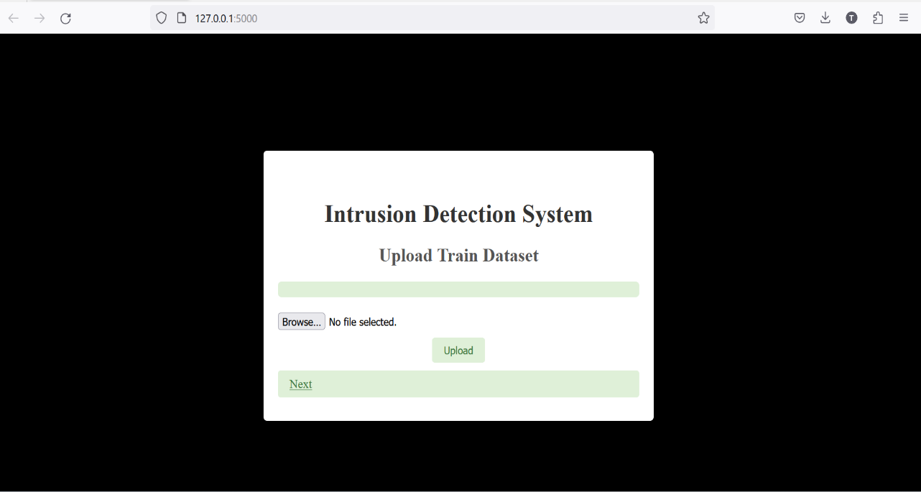

Figure 1.1

**Step 1: Upload the Training Dataset**

* Begin by uploading the training dataset in Excel format. This dataset will be used to train the data model.

**Step 2: Store Data in PostgreSQL Database**

* The uploaded data is stored in a PostgreSQL database in the form of a table, mirroring the structure of the Excel file. This database will serve as a centralized repository for your data.

**Step 3: Access Data on Demand**

* Users can access the stored data whenever required, ensuring easy and efficient data retrieval.

**Step 4: Upload the Test Dataset**

* Click 'Next' to proceed to the form page, where you can upload the test dataset file. This step is essential for evaluating the model's performance on unseen data.

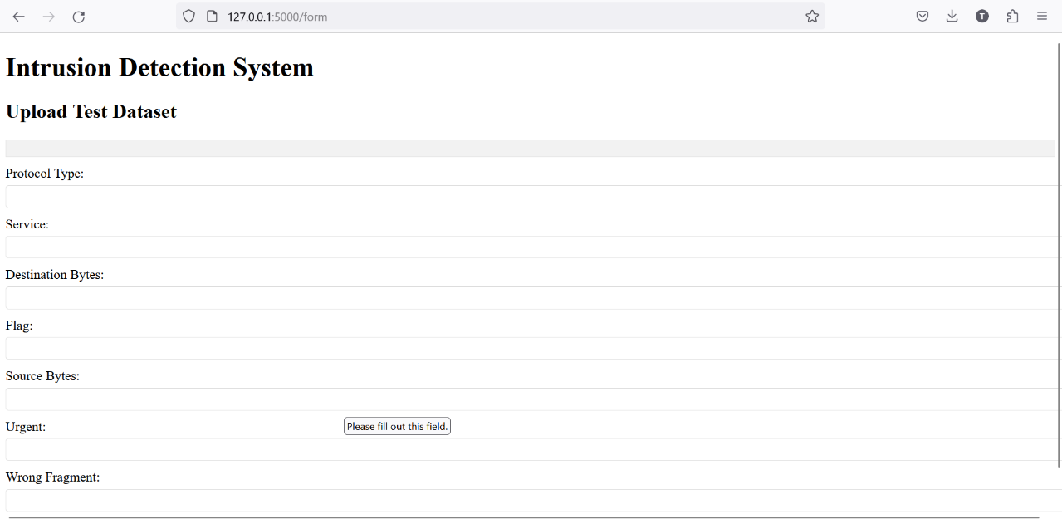

Figure 1.2

**Step 5: Submit Test Data**

* After uploading the test dataset, click the 'Submit' button to store this data in a new PostgreSQL database. This separate database will allow for the isolation of test data from the training data.

**Step 6: Access Test Data**

* Similar to Step 3, users can access the test data in the new PostgreSQL database when needed.

**Step 7: Compare Databases**

* By clicking 'Next,' you initiate the process of comparing the two databases: the one containing training data and the one containing test data. The comparison identifies similar data entries.

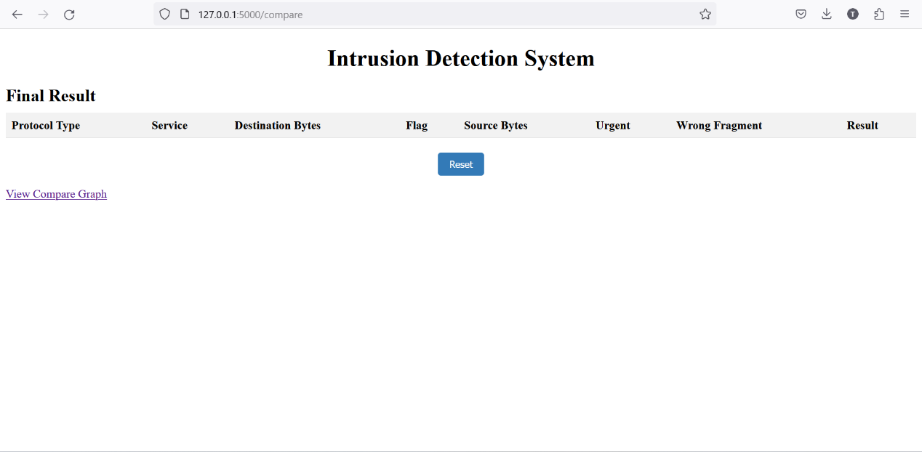

Figure 1.3

**Step 8: Presenting Results**

* The results of the database comparison are presented in a clear and professional format on the next template.

**Limitations and Future extensions**

**Limitations of Intrusion Detection Systems (IDS):**

1. **False Positives and Negatives:** IDSs can generate false alarms (false positives) or miss actual intrusions (false negatives). Achieving a balance between these two is a significant challenge.
2. **Signature-Based Limitations:** Traditional IDSs rely on known attack signatures, making them ineffective against zero-day attacks or novel threats not covered by existing signatures.
3. **Traffic Encryption:** IDSs may struggle to inspect encrypted traffic, limiting their ability to detect threats within encrypted communications.
4. **Resource Intensive:** Running IDSs in high-traffic environments can be resource-intensive, potentially causing network slowdowns or requiring significant hardware investments.
5. **Complexity:** Managing and tuning IDSs can be complex and time-consuming, requiring expertise in network security.
6. **Evasion Techniques:** Attackers can use evasion techniques to bypass IDSs, making them less effective against sophisticated threats.
7. **Anomaly Detection Challenges:** Anomaly-based IDSs may generate false positives due to legitimate changes in network behavior.
8. **Alert Overload:** IDSs can generate a high volume of alerts, overwhelming security teams and potentially causing important alerts to be overlooked.

**Future Extensions of Intrusion Detection Systems:**

1. **Machine Learning and AI:** Integrating machine learning and artificial intelligence into IDSs can enhance their ability to detect novel threats by learning from historical data.
2. **Behavioral Analysis:** Future IDSs may focus on behavioral analysis, looking for deviations from normal network behavior rather than relying solely on known attack signatures.
3. **Deep Packet Inspection:** Improvements in deep packet inspection techniques can enhance the ability to analyze encrypted traffic.
4. **Cloud Integration:** As organizations move to the cloud, IDSs will need to adapt to monitor and protect cloud-based assets effectively.
5. **IoT and OT Support:** Expanding IDS capabilities to include Internet of Things (IoT) and Operational Technology (OT) networks will be crucial as these environments become more interconnected.
6. **Automated Response:** IDSs can evolve to include automated response mechanisms, enabling real-time threat mitigation without human intervention.
7. **Threat Intelligence Integration:** Integration with threat intelligence feeds can provide IDSs with up-to-date information on emerging threats.
8. **User and Entity Behavior Analytics (UEBA):** Incorporating UEBA capabilities can help detect insider threats and compromised accounts by analyzing user and entity behavior patterns.
9. **Quantum Computing Defense:** Preparing IDSs for the challenges posed by quantum computing, which may potentially break current encryption methods, is essential.
10. **Human-Centric Design:** Future IDS interfaces should prioritize user-friendliness to reduce the burden on security personnel managing and responding to alerts

**CONCLUSION**

**Intrusion Detection Systems (IDS) are Crucial for Network Security as** IDSs are indispensable for enhancing network security, providing real-time monitoring, and alerting administrators to suspicious activities. They proactively detect cyber threats, minimizing downtime and service disruptions, and contribute to a comprehensive security strategy. However, striking the right balance between false positives and negatives remains a challenge, requiring ongoing tuning.

Effective IDS implementation involves integrating them with other security tools and processes, ensuring a holistic security approach. Regular updates to recognize new threats are essential, as is customization to match an organization's specific needs and scale. Compliance and reporting capabilities aid in meeting regulatory requirements, while user awareness and education play a vital role in an effective IDS strategy, collectively contributing to robust cybersecurity defenses. In conclusion, IDSs are sentinels in the ever-evolving cyber threat landscape, preserving the confidentiality, integrity, and availability of critical systems and data when integrated effectively.

**TECHNICAL BIOGRAPHY**



**Urmit Tajwala**

**B.Tech CSE (AIML) - Sem V**

**Enrollment no. 20210702089**

[**urmit21btai40@karnavatiuniversity.edu.in**](mailto:urmit21btai40@karnavatiuniversity.edu.in)